1. **ABOUT THE INSTITUTE**

Extension Education Institute (EEI) is a regional level institute with the main mandate of providing capacity building to middle level extension functionaries of the departments and organizations of agricultural development, particularly in the discipline of Extension Education. The Department of Agriculture and Cooperation (DAC), Ministry of Agriculture, Govt. of India has established four EEIs for four regions of the country: EEI (Southern Region) at Hyderabad, Andhra Pradesh, EEI (Northern Region) at Nilokheri, Haryana, EEI (Western Region) at Anand, Gujarat, and EEI (NE Region) at Jorhat, Assam. EEI (NE Region) was established in 1987 at Assam Agricultural University (AAU), Jorhat to cater to the need of capacity building of the extension functionaries of the NE states. It functions under the administrative control of Assam Agricultural University (AAU), Jorhat on the basis of annual *Memorandum of Understanding* between DAC, MoA, GOI, New Delhi and AAU, Jorhat. The DAC, MoA, GOI provides the fund for the institute under its non-plan budget head. The operational area of EEI (NE Region) covers nine states which include, Arunachal Pradesh, Assam, Manipur, Meghalaya, Mizoram, Nagaland, Sikkim, Tripura and West Bengal.

* 1. **Vision of the Institute**

Achieving excellence as a premier institute in facilitating capacity building of extension functionaries for sustainable development of agriculture in NE states of India.

* 1. **Mission of the Institute**
     + - Developing competencies of extension personnel in providing professional extension service to farming community.
       - Enhancing effectiveness of extension systems in planning, implementation, monitoring and evaluation of programmes and projects for sustainable agricultural development.
       - Developing and improving approaches, methodologies, tools and techniques relating to training and extension education.

The EEI Management Committee is the apex body of the institute. The Vice Chancellor, Assam Agricultural University is the Chairperson of the committee, and the Director, EEI is the Member Secretary. The Management Committee meeting is generally held once or twice in a year to review the performance of the institute, and to make policy decisions for its effective functioning. The Director of the Institute is responsible for managing its programmes and day-to-day management and administration. The Director works under the administrative control of the Vice Chancellor, AAU.

**1.3. Mandate of the Institute**

* + - * To develop competencies of middle level extension functionaries of client departments and organizations on application of advanced concepts, approaches, methodologies, tools and technologies of agricultural extension.
      * To build capacity of extension personnel for efficient dissemination of frontline agricultural technologies.
      * To facilitate extension systems and personnel in planning, implementation, monitoring and evaluation of agricultural development programmes and projects.
      * To provide demand driven consultancy services to agriculture and allied departments in planning, implementation, monitoring and evaluation of agricultural development programmes and to address issues relating to extension management.
      * To carry out action research in agricultural extension and training in order to bring improvement in approaches, methodologies, tools and techniques of training and extension education.

**1.4. The Training Planning Process**

Organizing training programmes on need based areas of capacity building of the concerned extension functionaries in the field of ‘Extension Education’ has been the main activity of the institute. However, since 2006-07, the institute started to organize a few of training courses per year on frontline agricultural technologies based on the identified training needs.

The district, sub-division and block level extension officers of the departments of Agriculture, Horticulture, Soil conservation, Animal Husbandry and Veterinary, Fishery and Sericulture are the core target groups of EEI's training courses. Trainers of KVKs and SAMETIs are the secondary group of intended trainees. The extension functionaries of NGOs are also invited to participate in some of the training courses. The institute sometimes organizes courses for field functionaries in order to meet special training needs of client departments.

EEI ( NE Region) identifies the training needs of its client departments every year in order to prepare its annual training calendar. The process starts during the month of January and completes within the month of March.

It comprises of 6 steps:

**Step 1**: Compilation of training needs obtained from the participants of the training programmes of previous year**.**

**Step 2:** Preparation of ‘Annual Training Need Assessment Questionnaire’ by utilizing information obtained through a number of ways:

**a)** Priority areas of on-going programmes/projects/schemes of agricultural development in the north-eastern states

**b)** Area of Training Needs of the participants of the current year’s training programmes of the institute. A Proforma is used to obtain training needs of each participant on the last day of each training programme of the institute

**c)** Task -analysis of intended targeted participants

**d)** Suggestion of the EEI Management Committee and the Directorate of Extension, Ministry of Agriculture, Govt. of India, New Delhi

**Step 3:** Obtaining areas of the training needs of the extension functionaries of various cadres of the relevant departments and organizations by mailing the questionnaires to the administrative heads.

**Step 4:** Finalization of thrust areas and themes of capacity building in the Annual Training Planning Workshop for MANAGE, EEIs and SAMETIs’ organized by MANAGE, Hyderabad.

**Step 5:** Updating of the training needs obtained as stated above in the Regional Workshop which is organized every year.

**Step 6:** Submission of proposed Annual Training Calendar to the Directorate of Extension, DAC, MoA, GOI for obtaining approval.

The Annual Training Calendar of EEI (NE Region) includes two types of training programmes:

**a) On-campus programmes:** The programmes are organized at the institute. These programmes are usually organized for extension functionaries of the client states.

**b) Off-campus programmes:** The programmes are organized in any of the client states other than Assam. The idea of organizing an **Off-Campus** course is to develop KAS of a group of officers of one or more departments of a particular client state on a need based training area.

In addition to the scheduled courses of annual training calendar, the institute has been conducting additional courses catering to the emerging needs of client departments. The institute is having competent faculty to take up consultancy service on agricultural extension management, planning, monitoring and evaluation of development projects, and to plan and implement capacity-building projects in the client states.

In addition to training programmes, the institute proposes research studies as per direction of competent authority.

**2. ACADEMIC PROGRAMMES CONDUCTED DURING 2017-18**

The salient aspects of different types of programme conducted by the institute in the current year i.e. 2017- 18 are:

**2.1.** Summary of the Academic Programmes conducted during 2017-18

**2.2.** Summary of On-campus programmes conducted during 2017-18

**2.3.** Summary of Off- campus programmes conducted during 2017-18

**2.4**. State-wise distribution of participants in the training programmes during 2017-18

**2.5**. Department / Discipline-wise distribution of participants in the programmes during 2017-18

**2.6**. Gender distribution of participants during 2017-18

**2.7.** Post Graduate Diploma in Agricultural Extension Management (PGDAEM)

**2.8.** Abstract of Academic Programmes conducted during 2017-18

**2.9.** Regional Workshop at Imphal, Manipur, Feb 2-3, 2018

**2.10**. Abstracts of Research studies

**2.11.** Skill Development Training

**2.12.** Significant events

**2.1. Summary of Academic programmes conducted during 2017-18**

The institute conducted the 28 training/workshops during 2017-18 out of which 9 were **On-Campus** training programmes, 18 **Off-Campus training** programmes and 1 Regional workshop. A total of 874 extension functionaries participated in the programmes. The targeted number of participants was 940 and thus, the percentage of seat utilization in the programmes of the year was 92.98 per cent. The percentage of seat utilization was 87.03 per cent in ‘On-Campus’ and 103.52 per cent in ‘Off-Campus’ programmes are given in Fig 1. Moreover, the institute conducted the Contact classes and corrected Answer scripts of PGDAEM programmes for two states, Assam and Nagaland.

**Fig.1: Percentage of seat utilization in ‘On’, ‘Off’ campus training programmes and Regional workshop during 2017-18**

**Table 2.1: Summary of the Academic Programmes conducted during 2017-18**

|  |  |  |  |  |  |
| --- | --- | --- | --- | --- | --- |
| Types of Programmes | Nos. of Programmes | | No. of participants | | Percentage of Seat utilization |
| Target | Conducted | Target | Attended |
| On campus | 9 | 9 | 270 | 235 | 87.03 |
| Off- campus | 19 | 18 | 570 | 559 | 103.50 |
| Regional Workshop | 1 | 1 | 100 | 80 | 80.00 |
| Total | 29 | 28 | 940 | 874 | 96.04 |

**2.2. Summary of On-Campus programmes conducted during 2017-18**

During 2017-18, the institute conducted 9 numbers of **On-Campus** training programmes in which 235 personnel participated while the targeted number of participants was 270. The details of the On-campus training programmes conducted during 2017-18 are shown in the Table 2.2.

**Table 2.2: On-campus training programmes conducted during 2017-18**

|  |  |  |  |  |  |
| --- | --- | --- | --- | --- | --- |
| SN | Course Title | Duration | No of targeted participants | No. of participants  attended | Percentage of Seat utilization |
| 1 | Skill development for m-Extension and e-Extension | 9-12th May, 2017 | 30 | 21 | 70.00 |
| 2 | Doubling farmer’s income through Community Organization and Entrepreneurship Development | 16-19th May, 2017 | 30 | 19 | 63.33 |
| 3 | Workshop on Harnessing Agri-Market Potential in NE states | 20-24th June 2017 | 30 | 27 | 90.00 |
| 4 | Gender friendly tools and practices, and extension approaches for mainstreaming farm women | 25-29th July, 2017 | 30 | 30 | 100.00 |
| 5 | Workshop on Climate Smart Agriculture and Disaster Management in NE States | 5-9th Sept.,2017 | 30 | 26 | 86.67 |
| 6 | Soft skills for Interpersonal Effectiveness and Approach towards Entrepreneurship Development | 12-16th Sept. 2017 | 30 | 32 | 106.67 |
| 7 | Management Games and Interactive Training Tools | 14-18th Nov., 2017 | 30 | 28 | 93.33 |
| 8 | Training Methods and Training Management Skills | 12-16th Dec., 2017 | 30 | 32 | 106.67 |
| 9 | Managerial Skills and Leadership Development | 6-10th Feb., 2018 | 30 | 20 | 66.67 |
| Total | | | **270** | **235** | **87.03** |

Table 2.2 shows that the overall percentage of seat utilization was 87.03 per cent in **On-campus** courses. In case of 2 numbers of courses, the percentage of seat utilizations were more than 100 percent. In 7 numbers of courses the percentage of seat utilization ranged from 60 to 100 percent .

**2.3. Summary of Off-Campus programmes conducted during 2017-18**

The institute conducted 18 numbers of Off-campus courses during the year 2017-18 covering 9 states viz. Assam, Tripura, Nagaland, Sikkim, West Bengal, Arunachal Pradesh, Manipur, Mizoram and Meghalaya. As shown in the Table 2.3, the participation of officers in all the 18 nos. of off-campus programmes was encouraging. The total number of participants in the 18 off-campus courses were 559 while targeted number of participants was 570, and thus, the overall percentage of seat-utilization was 98.07 percent.

**Table 2.3: Off-campus training programmes conducted during 2017-18**

|  |  |  |  |  |  |  |
| --- | --- | --- | --- | --- | --- | --- |
| SN | Course Title | Duration  (4 days) | States | No. of targeted participants | No. of participants attended | Percentage of seat utilization |
|  | Communication and Training Skills for Efficient Extension Service | 23-26th May, 2017 | SAMETI, Manipur | 30 | 29 | 96.66 |
|  | Training Methods and Training Management Skills | 14-17th June, 2017 | SAMETI, Nagaland | 30 | 30 | 100.00 |
|  | Training on Organic Farming and INM | 13-16th June, 2017 | SAMETI, Mizoram | 30 | 33 | 110.00 |
|  | Use of Social Media and Low Cost Videography | 27-30th June, 2017 | SAMETI, Assam | 30 | 27 | 90.00 |
|  | Designing and Management of Skill Development Training Programmes | 11-14th July, 2017 | T-SAMETI, Tripura | 30 | 30 | 100.00 |
|  | Training on Organic Farming and INM | 18-21st July 2017 | SAMETI, Nagaland | 30 | 30 | 100.00 |
|  | Organic Farming Techniques and Organic Certification | 1-4th Aug. 2017 | SAMETI, Arunachal Pradesh | 30 | 31 | 103.33 |
|  | Training Methods and Training Management Skills | 28-31st Aug. 2017 | SAMETI, Sikkim | 30 | 34 | 113.33 |
|  | Extension Skills for Implementation of Major Agricultural Development Schemes | 19-22nd Sept., 2017 | MAMETI, Meghalaya | 30 | 34 | 113.33 |
|  | Workshop on Climate Smart Agriculture and Efficient Water Management | 19-22nd Sept., 2017 | SAMETI, Assam | 30 | 35 | 116.66 |
|  | Managerial Skills and Leadership Development | 24-27th Oct., 2017 | SAMETI, Arunachal Pradesh | 30 | 30 | 100.00 |
|  | Methods and Skills for Community Organization and Entrepreneurship Development | 7-10th Nov., 2017 | MAMETI, Meghalaya | 30 | 30 | 100.00 |
|  | Methods and Skills for Community Organization and Entrepreneurship Development | 27-30th Nov., 2017 | T-SAMETI, Tripura | 30 | 31 | 103.33 |
|  | Precision Farming and its Relevance to Commercialization of Horticultural Crops | 12-15th Dec., 2017 | SAMETI, West Bengal | 30 | 30 | 100.00 |
|  | ICT in Agricultural Extension focusing on Mobile Apps and FCMS Applications | 9-12 Jan., 2018 | SAMETI, Assam | 30 | 26 | 86.67 |
|  | Designing and Management of Skill development training programmes | 17-20th Jan.,2017 | SAMETI, Mizoram | 30 | 28 | 93.33 |
|  | Management Games and Interactive Training Tools | 6-9th March, 2018 | SAMETI, Sikkim | 30 | 30 | 100.00 |
|  | Leadership and Team Building for Extension Personnel | 21-24th March, 2018 | SAMETI, Manipur | 30 | 41 | 136.67 |
| Total | | | | 540 | 559 | 103.51 |

**2.4. State-wise distribution of participants in training programmes and workshops during 2017-18**

The distribution of participants across the states is shown in Fig.2. The state-wise distribution of data is presented at Appendix I (Table 2). From the figure, it could be seen that Assam is having the highest numbers (218) of participants followed by Manipur (156), Meghalaya (100), Nagaland (79), Arunachal Pradesh (77), Mizoram (76), Sikkim (72), Tripura (65) and West Bengal (31).

**Fig.2: State-wise distribution of participants in training programmes and workshops during 2017-18**

**2.5. Department / Discipline wise distribution of participants in the Training programmes during 2017 -18**

The distribution of participants across departments/discipline is shown in (Fig.3).  
It can be seen from the fig. that the majority (501) of the participants was from ATMA/SAMETI, while 228 were from Agriculture and Horticulture department. There were98 participants from KVK/ICAR/SAU, 29 from fishery and 18 participants Animal Husbandry and Sericulture. The details of department/discipline wise distribution of participants, is given at Appendix II (Table 3).

**Fig. 3: Department/Discipline wise distribution of participants in programmes during 2017 -18**

**2.6. Gender distribution of participants during 2017-18**

The gender distribution of participants during 2017-18 is given in Fig.4 and the detailed distribution data is presented at Table: 4 (Appendix III). Efforts were being made to enhance women participation. During 2017-18, women participation was 339 (38.78%) as against male participation which was 535 (61.22%).

**Fig.4. Gender distribution of participants during 2017-18**

**2.7. Post Graduate Diploma in Agricultural Extension Management (PGDAEM)**

EEI (NE Region) has been implementing Post Graduate Diploma in Agricultural Extension Management (PGDAEM) as study centre for the state of Assam since 2010-11 and for the state of Nagaland since 2011-12 in collaboration with SAMETI, Assam and SAMETI, Nagaland. The table below, presents brief statement of this programme of distant mode of learning on Extension Education implemented by MANAGE, Hyderabad since 2007-08. From the year 2013 to 2017, a total of 204 candidates successfully completed the PGDAEM Programme from the states of Assam and Nagaland. The status of PGDAEM in the states of Assam and Nagaland are given below.

**Table.2.7: Status of PGDAEM in the states of Assam and Nagaland**

|  |  |  |  |  |
| --- | --- | --- | --- | --- |
| **State** | **Year** | | **No. of candidates enrolled** | **No. of candidates successfully completed** |
| Assam | 2013-14 | 1st semester | 18 | 18 |
| 2nd semester | 18 | 18 |
| 2014-15 | 1st semester | 08 | 08 |
| 2nd semester | 08 | 08 |
| 2015-16 | 1st semester | 13 | 13 |
| 2nd semester | 13 | 13 |
| 2016-17 | 1st semester | 14 | 13 |
| 2nd semester | 14 | 13 |
| Nagaland | 2013-14 | 1st semester | 13 | 13 |
| 2nd semester | 13 | 13 |
| 2014-15 | 1st semester | 21 | 17 |
| 2nd semester | 21 | 17 |
| 2015-16 | 1st semester | 7 | 7 |
| 2nd semester | 7 | 7 |
| 2016-17 | 1st semester | 8 | 8 |
| 2nd semester | 8 | 8 |

**2.8. Abstract of Training Programme 2017-18**

1. **Skill Development for M- Extension & E-Extension with special focus on Cashless Transaction and Direct Benefit Transfer, May 9-12, 2017, EEI (NE Region)**

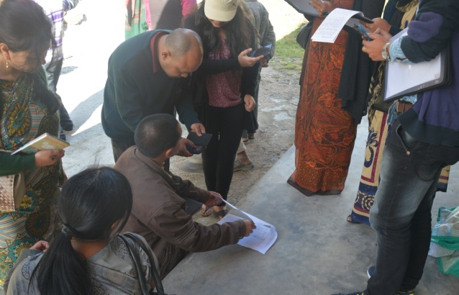Mobile-based extension and advisory services (m-Extension) are location specific and, at the same time, able to transcend geographic limitations. A training programme was organised on **“**Skill Development for M- Extension & E-Extension with special focus on Cashless Transaction and Direct Benefit Transfer” at EEI (NE Region), Jorhat during **May 9-12, 2017.** Faculty members of EEI (NE Region) along with experts State Bank of India conducted different sessions on topics like: ICT applications in Agricultural Extension work and recent advances, Internet Based ICT tools for technology transfer in Agricultural Extension, Social Media for use in Extension, Techniques of video production, Brief theoretical orientation on vegetative propagation of horticultural crops and hydroponics, Important Websites in Agriculture and Extension, Cashless Transactions and Direct Benefit Transfer, m-Extension and its applications, Mobile Apps in agriculture / extension offered by Govt. of India, e-NAM, Kisan Call Centre and Flagship ICT initiatives of GOI etc. Total 21 extension functionaries from Dept. of Agriculture, ATMA and KVKs from whole North East region participated in the programme.

1. **Doubling farmer’s income through Community Organization and Entrepreneurship Development**

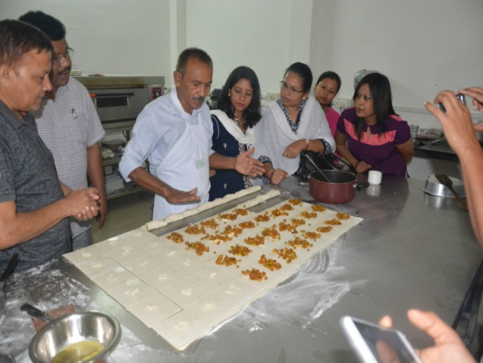Indian agricultureis passing through difficult times due to two consecutive drought situations in several parts of the country, thereby resulting into wide spread distress among farmers. The rural areas in these parts are facing food and livelihood crisis, more specifically the shortage of fodder and drinking water. Government needs to proactively address the situation and make more long term farmers centric policies related to irrigation, farm diversification, farm profitability and community support programs so as to socially and economically empower farmers. In this context, Government announced to double the income of farmers by 2022. Keeping this in view, a training programme on “Doubling farmer’s income through Community Organization and Entrepreneurship Development” was organised at EEI (NE Region), Jorhat during **May 16th -19th, 2017**. The sessions of the programme mainly focused on: An overview on the strategies of doubling farmers income in the Indian context, Skills needed for team building and teamwork for streamlining farmers’ efforts, Concept, Characteristics and qualities of entrepreneurs, Managerial Skills Needed for Entrepreneurship, Role of Commodity Interest Groups(CIGs) and Farmers Organizations in community life of the region, Agri-entrepreneurship development in ACABC Schemes: Guidelines and sharing experience, Phases of Entrepreneurship Development and Risk Analysis in Enterprise Management, Flagship Programmes of GOI related to Entrepreneurship Development, e-NAM and Mobile Apps of GOI etc. Total nineteen extension functionaries from Dept. of Agriculture, ATMA and KVKs from different states of North East region participated in the programme.

1. **Workshop on Harnessing Agri-Market Potential in NE states**

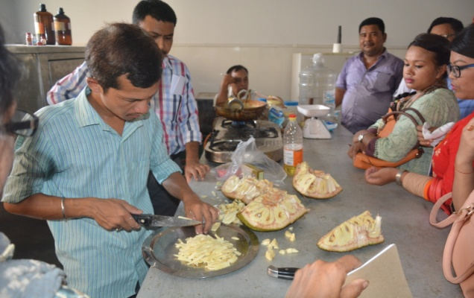Income of rural consumer depends upon the efficiency of marketing of agricultural produce irrespective of the technology adopted in production. Any technology Innovation should go hand in hand with efficient marketing. Keeping this in view, a 5 days’ workshop was conducted at EEI (NE Region), Jorhat during **June 20-24, 2017**. Total 27 Extension Functionaries from different states of North-East region were participated in the workshop. Faculty members of EEI (NE Region) along with experts from Dept. of Agricultural Economics and Farm Management and Dept. of Horticulture conducted different sessions. Production Economics with relevance to extension in NE states, Identification of market potentialities in NE Region, Marketing management – types of markets, Marketing mix, Use of social media for Agril. Marketing, M-Extension, E-extension and its applications for Agril. Marketing, Cashless Transactions and Direct Benefit Transfer, Entrepreneurship dev for Agril. Marketing etc. were discussed during the programme.

1. **Gender friendly tools and practices, and extension approaches for mainstreaming farm women**

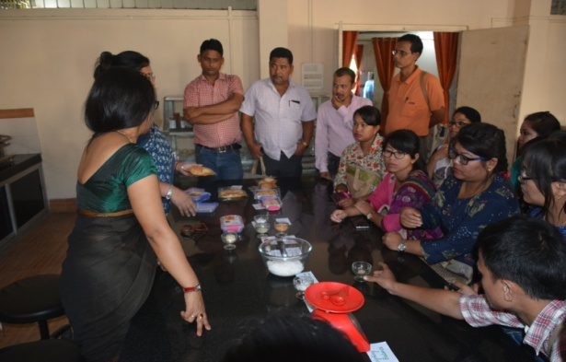It is gender that differentiates the roles, responsibilities, resources, constraints and opportunities of women and men in agriculture for which precise gender information is the need of the day, more particularly overcome the gender obstacles, enduring efforts to mainstream gender in agriculture, establishing gender friendly small scale agro based enterprises. During **July 25-29, 2017** a training was organized at EEI (NE Region), Jorhat on “Gender friendly tools and practices, and extension approaches for mainstreaming farm women” for the extension functionaries of all the agricultural and allied sector department. The participants were discussed with the topics like: Gender analysis, Gender Budgeting, Gender Mainstreaming, Gender Friendly Tools and Implements in NE States, Doubling farmers income and Govt. initiatives for Farm Women Empowerment, Gender Friendly Small Scale Agro-Based Enterprises for NE Region, SHG and Microfinance in women empowerment, Govt. schemes and programmes for women, Extension strategies for promoting Gender Friendly tools for farm women, Public Private Partnership(PPP) for Gender Mainstreaming in Agro based Enterprises etc.Total thirty extension officers from all over North Eastern region participated in the programme.

1. **Workshop on Climate Smart Agriculture and Disaster Management in NE States**

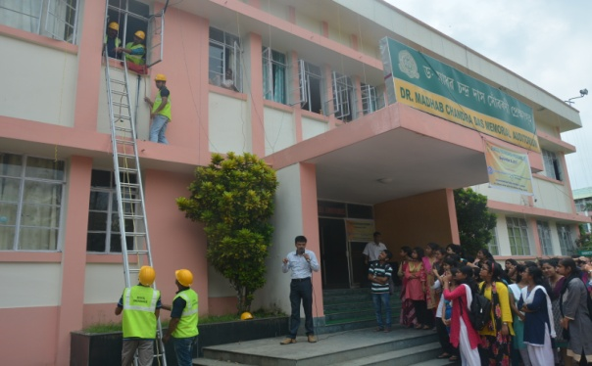Widespread changes of climatic factors like rainfall and temperature threaten agriculture production and increase the vulnerability of people mostly, depending on agriculture. Climate Smart Agriculture (CSA) is an approach for transforming and reorienting agriculture systems under the new realities of climate change. CSA brings together practices, policies and institutions that are not necessarily new but are used in the context of climatic changes, which are unfamiliar to farmers, herders and fishers. What is also new is the fact that the multiple challenges faced by agriculture and food systems are addressed simultaneously and holistically, which helps avoid counterproductive policies, legislation or financing. Therefore to aware about Climate Smart Agriculture a training programme was organized during **Sept. 5-9, 2017** at EEI (NE Region) for the extension functionaries of whole North Eastern region. The sessions of the programme mainly focused on: Need and Relevance of CSA in present context in NE states, Building climate resilient Agriculture for rice based cropping system of Assam, Contingency crop planning for management of weather aberrations, Issues on agriculture and allied sectors relating to climate change and measures to be adopted, Challenge of mitigating impact of climate change on rice productivity: A biotechnological perspective, Climate variability in NE India, Climate smart practices in agriculture as recommended by CRIDA & FAO, Types of Disaster: An overview, Community based Disaster Management, Use of ICT tools for Disaster Management, A Systematic Approach (ASA) for Disaster Management, Pest and Disease Management in Post Flood Situation etc. Exposure visit was done to the Agro-met observatory centre of AAU, Jorhat. Twenty six extension functionaries from Dept. of Agriculture, ATMA and KVKs participated in the programme. A field visit was organised to the flood prone village Kumolia Chapori, jorhat which is about 20km away from the centre. On behalf of EEI (NER), some planting materials and seeds for the next cropping season were distributed among the flood affected farmers of the village. Out of affection, all the twenty six (26) participants from the different states of North East including Manipur, Meghalaya, Nagaland, Arunachal Pradesh, Sikkim and Assam also donated a sum of Rs.6200.00 to the flood affected people for their wellbeing. The workshop ended on Sept. 9th, 2017 and all the participants expressed great satisfaction towards the programme.

1. **Soft Skills for Interpersonal Effectiveness and Approach towards Entrepreneurship Development**

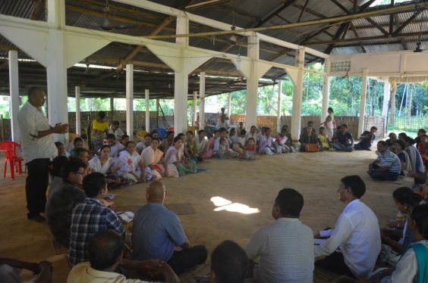Soft skills are the cluster of personality traits, social graces, communication skills, personal habits, friendliness and optimism that mark people to varying degrees. Soft skills enable individuals to effectively utilize hard skills (technical competence) in doing a job effectively. Soft skills are an important part of the success of an individual affecting an organization. Organizations become effective as soft skills enable the staff to deal with clients / customers better. Hence, Soft skills are increasingly treated by managers / employers as essential requirement of personnel. During **Sept. 12-16, 2017** a training programme on “Soft Skills for Interpersonal Effectiveness and Approach towards Entrepreneurship Development” was organised for the Extension Functionaries of all North Eastern states. The topic of discussion during those five days were: Orientation on Soft Skills, Practical tips on Professional Communication, Up-scaling Communication Skills, Presentation Skills for Effective Communication, Interpersonal Effectiveness: Principles and Practices, Critical aspects relating to delegation, Self Awareness and Self Regulation, Soft Skills on Listening, Empathy and Feedback, Social Value Orientation, Managing your ego and ego gram, Entrepreneurship: Planning and Establishment of Enterprises, Market Linkages and Support for Rural Enterprises, Entrepreneurial Qualities and Managerial Functions etc. A total of thirty two participants from Dept. of Agriculture, ATMA and KVKs participated in the programme. A field visit was conducted to the village Jatakia near ‘Gibbon Wildlife Sanctuary’ where feasible biodiversity conservation model was demonstrated to the framers by the participants. A discussion on different integrated farming system model relevant to the village situation made the visit a successful one. All the participants and villagers expressed greater satisfaction over the programme.

1. **Management Games and Interactive Training Tools**

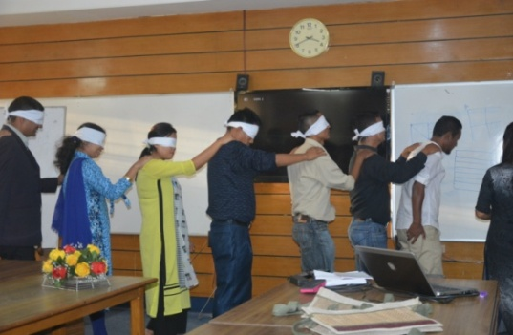 Management is an art or science is debatable. But one thing which is sure is that importance of management functions, learning basic management concepts and its application in day to day activity of corporate world has achieved tremendous acceptance in recent years. Over last couple of years, pedagogy in the management education is changing very fast, and one of the latest additions in this field is the management games. Based on the basic theoretical frameworks of management domains, several games are designed, which are focused at the basic and fundamental principles of management. Generally these games are played both individually and in teams. Major objective of these games is to enhance the eye for details, to improve analyzing skills, to enable quick decision making, to make students cooperative and team players, and to give them long lasting impressions of the subjects, which they have learnt inside classrooms. A 5-day training programme on “Management Games and Interactive Training Tools” was organised during **Nov. 14-18, 2017** by EEI (NE Region) for the Extension Functionaries of different states of North East Region. The participants were discuss and play games on Time management, Ego management, Conflict management, Team building, Communication, Leadership, Balancing work – life, Unity etc. A total of twenty eight participants from Dept. of Agriculture, ATMA and KVKs participated in the programme from different states of North East.

1. **Training Methods and Training Management skills**

In the fast changing world scenario, where repeated exposure of ever- increasing knowledge and sophisticated technology are occurring in quick succession, it is essential that all the human resources at different levels should work at a very high level of efficiency. For this, the frequent and regular training of these human resources becomes absolutely indispensable. Of the different activities of training, training methods assume the greater significance for the expected terminal behaviour in the trainees. With this aim, a training programme on “Training Methods and Training Management skills” was arranged during **Dec. 12-16, 2017** for the Extension Functionaries of whole North Eastern Region. The topic of discussion for those 5 days were: Designing Training Programmes and formulation of Training Objectives, Important guidelines for Lesson Planning in Training Programmes, An overview of Training Methods, Practice on Lesson Planning and 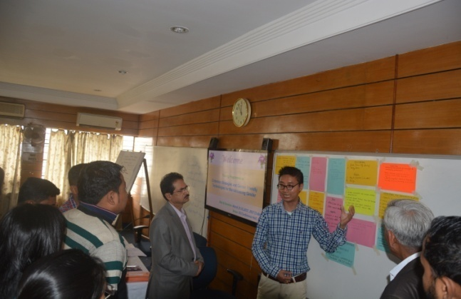Training Programme Designing, An overview of Low cost A.V Aids, Concept and Techniques of conducting Method Demonstration, Concepts, Practices and Principles of conducting Brainstorming Session and Buzz session, Tips of conducting Focused Group Discussion, ‘Do’s and ‘Don’ts in conducting training programme, Developing Case lets and Success Stories for use in training, Training Monitoring and Evaluation etc. Thirty two Extension Functionaries from Dept. of Agriculture, ATMA and KVKs were participated in the programme.

1. **Managerial Skills and Leadership Development**

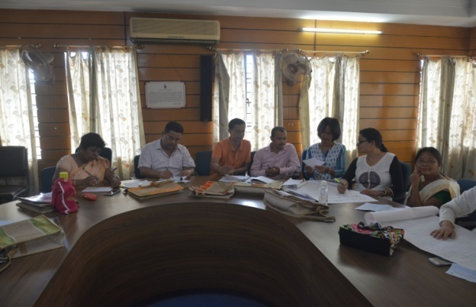A training programme on “Managerial Skills and Leadership Development” was organised at EEI (NE Region), Jorhat during **Dec. 12-16, 2017**. The topics discussed during different session of the training programme were: An overview of Designing Training Programmes, Concept and Features of Management Practices, Entrepreneurship: Concept, Entrepreneurial Qualities and Managerial Functions, Critical aspects relating to delegation, Communication skills: Verbal and Non Verbal, Self awareness and Self Regulation for personal effectiveness, Conflict Management for Group Sustainability, Concept of project and project cycle, Skills Needed for Teamwork etc. Total 20 participants participated in the programme.

1. **Communication and Training skills for efficient Extension service**

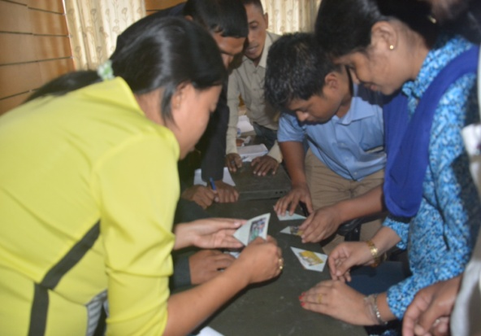A training programme on “Communication and Training skills for efficient Extension” was organised by EEI (NE Region), Jorhat during **May 23-26, 2017**, at Manipur with the collaboration of SAMETI, Manipur. Total 29 participants participated in the programme. The topics discussed during different session of the training programme were: Communication & Training- their importance in Agricultural Extension, Types of Communication & Various Communication Methods, Few selected Individual Methods of communication effective for Extension Work -Farm & Home Visit, Advantages & Disadvantages of Individual Methods, Few selected Group Communication Methods: MD, Buzz Session, Brainstorming, Meetings, Mass Media, ICT Tools and Websites including Social Media, Training Concept & Phases, Various Training Methods useful in Extension Work etc. Total 29 participants participated in the programme.

1. **Training Methods and Training Management skills**

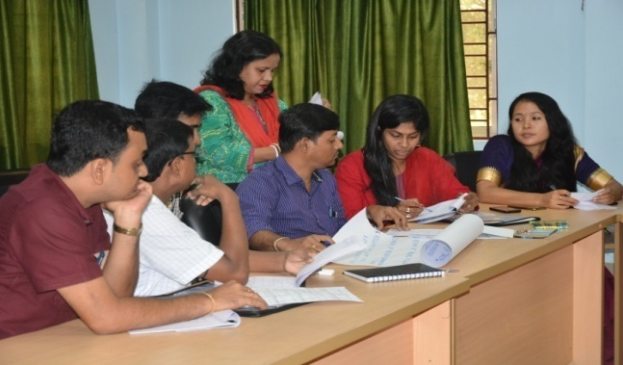 A training programme on “Training Methods and Training Management skills” was arranged during **June 6-9, 2017** by EEI (NE Region) at Nagaland, with the collaboration of SAMETI, Nagaland. Resource person from EEI (NE Region) has been conducted different session on: Concept of training, training need, training objectives, training methods and an overview of training designing, Formulation of training objectives, Training designing, Concept and tips of conducting Method Demonstration and Group Discussion, Concept and conducting tips of : Participatory Lecture, SFI, Co-training and Field Day, Experiential Learning Cycle (ELC) and Adult Learning principles, An overview of low-cost AV Aids, Concept, practices and principles of conducting brainstorming session, Principles of conducting Buzz group session, Overview of training checklist etc. Total 30 participants participated in the programme.

1. **Organic Farming and INM**

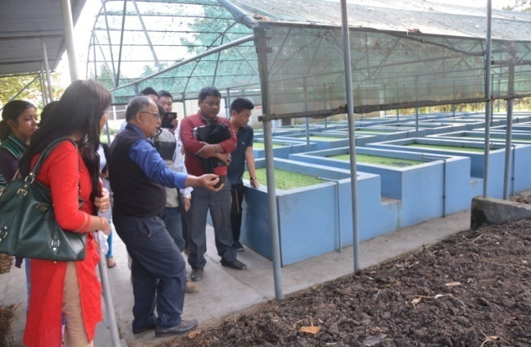 A training programme on “Organic Farming and INM” was organised by EEI (NE Region), Jorhat during **June 12-15, 2017**, at Mizoram with the collaboration of SAMETI, Mizoram. The topic discussed during different session of the training programme were: An overview on Paramparagat Krishi Vikash Yojana (PKVY), Prospects of Organic Agriculture in NE states with special reference to Mizoram, Raising Organic Nursery and Organic Seed Production, Production and application of biofertilizers as a component of organic farming, An overview on composting- its methods of preparation and application, Participatory Guarantee System in Organic Farming (PGS), Importance and cultivation technique of Azolla, Integrated Nutrient Management (INM), Ways and means of organic standard in organic agriculture etc. Total 33 participants participated in the programme.

1. **Use of Social Media and Low cost Videography**

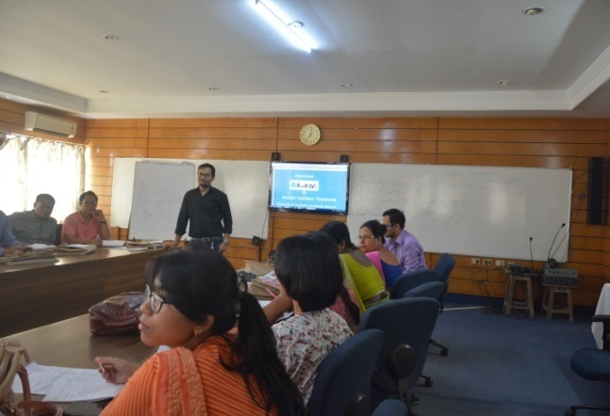Social networking media has now become a highlight in the realm of agricultural development due to its impact on the users. Over the years, the use of media, websites and applications like face book, Telegram, Twitter, Whatsapp etc. has multiplied into more than a billion users. Keeping this in view, a training programme on “Use of Social Media and Low Cost Videography” was organised by EEI (NE Region), Jorhat during **June 27-30, 2017**, at Assam, with the collaboration of SAMETI, Assam. Different session was conducted on topics like: ICT Tools and applications in Agricultural Extension, Social Media for use in Extension, Techniques of video production, Important Websites in Agriculture and Extension, M-Extension and its applications, Multimedia Production Tools, Mobile Apps in agriculture / extension offered by Govt. of India, e-NAM (e-National Agricultural Market), Kisan Call Centre and Flagship ICT initiatives of GOI, etc. Total 27 participants participated in the programme.

1. **Designing and Management of Skill Development Training Programmes**

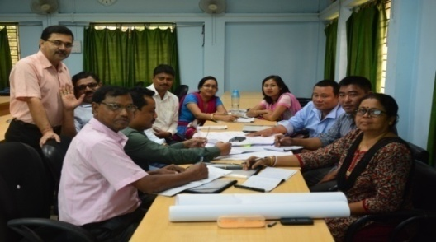The course emphasized on the crucial aspects on PMKVY, STRY and training module preparation. The training was held at T-SAMETI, Tripura from July 11th to 14th, 2017 and a total of thirty (30) participants from the department of Agri, Fishery, Vety as well as ATMA and KVKs of Tripura participated in the programme. The steps to be followed in training module preparation were practised in groups inside and outside the class room situation. A field visit was conducted to the village at Lambucherra for training need assessment on skill based training. Participants assessed training needs of the farmers for up scaling their technical knowledge so as to develop a proper training design and module to conduct training based on the training needs effectively. Positive feedback received from all the participants regarding content, various sessions, training methodology followed, food, lodging and other facilities provided during the programme. The participants expressed their keen interest to learn about designing and management of skill development training programmes and expressed great satisfaction over the programme.

1. **Organic Farming and INM**

From **July 18-21, 2017**, a training programme on “Organic Farming and INM” was organised by EEI (NE Region), Jorhat at Nagaland with the collaboration of SAMETI, Nagaland. The topic discussed during different session of the training programme were: An overview on Paramparagat Krishi Vikash Yojana (PKVY), Prospects of Organic Agriculture in NE states with special reference to Mizoram, Raising Organic Nursery and Organic Seed Production, Production and application of biofertilizers as a component of 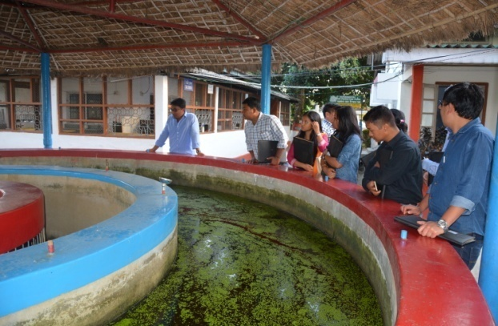organic farming, An overview on composting- its methods of preparation and application, Participatory Guarantee System in Organic Farming (PGS), Importance and cultivation technique of Azolla, Integrated Nutrient Management (INM), Ways and means of organic standard in organic agriculture etc. Total 30 participants participated in the programme. A field visit was conducted to the village Kukidolong which is about 5 km away from SAMETI, Medziphema. The group of 30 participants along with resource persons on behalf of EEI (NER) visited the composting and azolla cultivation unit present at the village. Dr. R. Baruah, Professor, Deptt of Soil Science, AAU, Jorhat had acted as an expert and one of the resource persons during the programme and highlighted the procedure while demonstrating the azolla cultivation practice.

1. **Organic Farming Techniques and Organic Certification**

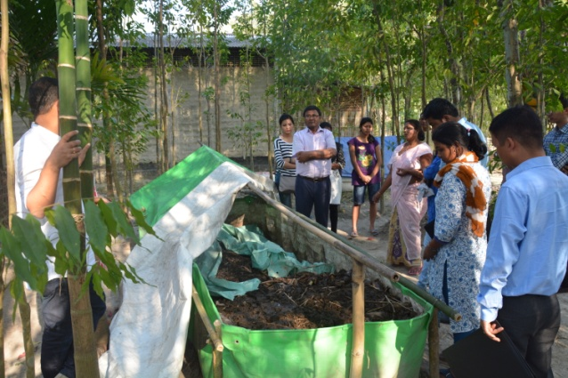 A training programme on “Organic Farming Techniques and Organic Certification” was organised by EEI (NE Region), Jorhat during **August 1-5, 2017**, at Arunachal Pradesh with the collaboration of SAMETI, Arunachal Pradesh. The topic discussed during different session of the training programme were: An overview on Paramparagat Krishi Vikas Yojana (PKVY), Prospects of Organic Agriculture in NE states with special reference to Mizoram, Raising Organic Nursery and Organic Seed Production, Production and application of bio fertilizers as a component of organic farming, An overview on composting- its methods of preparation and application, Participatory Guarantee System in Organic Farming (PGS), Importance and cultivation technique of Azolla, Integrated Nutrient Management (INM), Ways and means of organic standard in organic agriculture etc. Total 31 participants participated in the programme. A field visit was conducted to the drip irrigation demonstration farm and horticultural orchard present in the Central Agricultural University campus, where, applications of improved technology of organic farming techniques were demonstrated under the guidance of expert Dr. B. Deka who also acted as a resource person during the programme.

1. **Training Methods and Training Management skills**

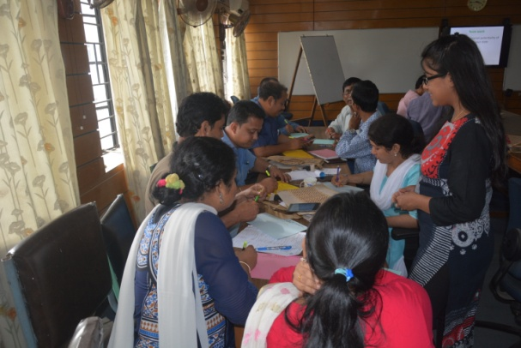 During **August 28-31, 2017** a training programme on “Training Methods and Training Management skills” was arranged by EEI (NE Region) at Sikkim, with the collaboration of SAMETI, Sikkim. Resource person from EEI (NE Region) has been conducted different session on: Concept of training, training need, training objectives, training methods and an overview of training designing, Formulation of training objectives, Training designing, Concept and tips of conducting Method Demonstration and Group Discussion, Concept and conducting tips of : Participatory Lecture, SFI, Co-training and Field Day, Experiential Learning Cycle (ELC) and Adult Learning principles, An overview of low-cost AV Aids, Concept, practices and principles of conducting brainstorming session, Principles of conducting Buzz group session, Overview of training checklist etc. Total 34 participants participated in the programme.

1. **Extension skills for implementation of major Agricultural Development Scheme.**

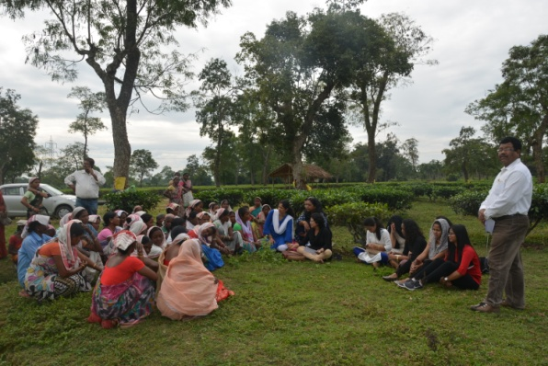The off campus programme was held in collaboration with MAMETI, Meghalaya from **Sept. 19th to 22nd, 2017** at Integrated Agriculture Training Centre, Upper Shillong. The course emphasized on the provisions made under the central sector scheme of STRY, Soil health card scheme, PKVY, PMFBY, RGM and PM-SAGY, DDUGJY, and DDUGKY and few other Central Sector Schemes of DAC, Govt. of India. A field visit was conducted to a successful floriculture entrepreneurial farm present in the Mylliem Block. Total 34 participants along with the resource persons and staff of MAMETI, Shillong visited the floriculture farm and discussed regarding the innovative techniques of flower production employed by the entrepreneur and the participants were motivated to set up such enterprises in their job area.

1. **Workshop on Climate Smart Agriculture and Efficient Water Management**

Climate Smart Agriculture (CSA) is an approach for transforming and reorienting agriculture systems under the new realities of climate change. CSA brings together practices, policies and institutions that are not necessarily new but are used in the context of climatic changes, which are unfamiliar to farmers, herders and fishers. Keeping this in view, a Workshop on “Climate Smart Agriculture and Efficient Water Management” was organised during **Sept. 19-22, 2017** by EEI (NE Region) at Assam, with the collaboration of SAMETI, Assam. The participant were discussed about Need and Relevance of CSA in present context in NE states, Agro-met advisory services for Climate Smart Agriculture, Carbon Sequestration with special reference to Bamboo Plantation, Building climate resilient Agriculture for rice based cropping system of 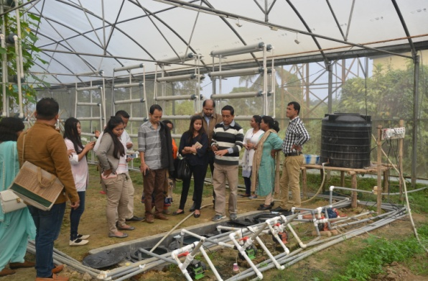Assam, Contingency crop planning for management of weather aberrations, Green House Effect and Protected cultivation, Agricultural Contingency Planning for Crop Production- Sharing experiences, Efficient Water Management for sustainable crop production, Indigenous coping strategies in Climate change adaptation, Climate smart practices in agriculture as recommended by CRIDA & FAO, Recent advances in water management practices and Drip Irrigation systems, Approaches for efficient soil and water management etc. A field visit was also arranged to a Water Management Technology at HRS farm, Kahikuchi. Total 30 participants participated in the programme.

1. **Managerial Skills and Leadership Development**

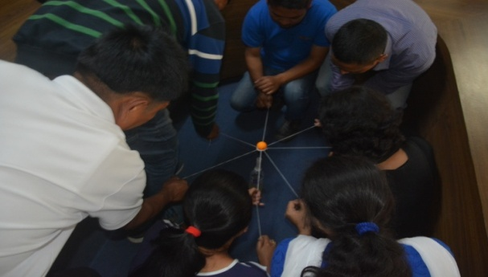A training programme on “Managerial Skills and Leadership Development” was organised by EEI (NE Region), Jorhat during **Oct. 24-27, 2017**, at Arunachal Pradesh with the collaboration of SAMETI, Arunachal Pradesh. The topics discussed during different session of the training programme were: An overview of Designing Training Programmes, Concept and Features of Management Practices, Entrepreneurship: Concept, Entrepreneurial Qualities and Managerial Functions, Critical aspects relating to delegation, Communication skills: Verbal and Non Verbal, Self awareness and Self Regulation for personal effectiveness, Conflict Management for Group Sustainability, Concept of project and project cycle, Skills Needed for Teamwork etc. Total 30 participants participated in the programme.

1. **ICT in Agricultural Extension focusing on Mobile Apps and FCMS Application**

A training on “ICT in Agricultural Extension focusing on Mobile Apps and FCMS Application” was organised at EEI (NE Region), Jorhat during **Jan. 9-12, 2018.** The topics discussed during different session of the training programme were: Importance of ICTs in Agricultural Extension, ICTs- tools and application in agricultural extension, Problems and prospects/ opportunities in application of ICT, Mobile apps and its application in agricultural extension, Social media as a tool for extension, Farm Crop Management System application, Global Farming Management Apps- *Their uses,* Successful ICT Projects- e-Choupal, E-arik, MSSRF- VRCs etc. total 29 participants from different district of Assam participated in the programme. As a part of Training Programme participants were visited the Kisan Call Centre (KCC) situated at Rukmini Gaon, Khanapara, Guwahati. Director, IFFCO addressed the participants and explained the mechanism of KCC which is handled by IFFCO. Participants got acquainted with the whole process of KCC and also how to handle the call of farmers under the guidance of Mr. Gunin Roy, Supervisor of KCC. Participants were motivated after having discussion with the Director, IFFCO to aware farmers about the KCC and also motivate them to contact KCC for their quarries related to farming.

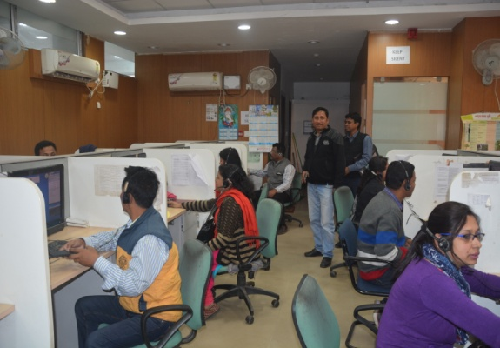

1. **Methods and Skills for Community Organisation and Entrepreneurship Development**

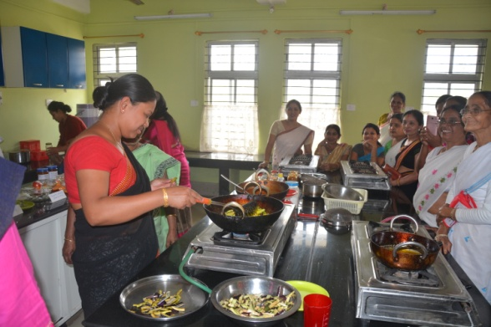A training programme on “Methods and Skills for Community Organisation and Entrepreneurship Development” was organised by EEI (NE Region), Jorhat during **Dec. 17-20, 2017**, at Meghalaya with the collaboration of MAMETI, Meghalaya. The topics discussed during different session of the training programme were: Concept, role , importance and achievements of SAMETI, Assam since inception, Duties and responsibilities of the office bearer s at state, district and block level in the institutional set up of extension reform policy, Importance of group led extension and the initiatives taken under extension reform, Guidelines and steps of formation and promotion of CIG and Farm school under ATMA, Stages of group development and role of extension agents in different stages, Tips of success story writing, FSI for Problem identification and solution, Leadership development for group sustainability, Conflict management for group development, Need of Savings and credit linkages for group development etc.

1. **Precision Farming and its Relevance to Commercialization of Horticultural Crops**

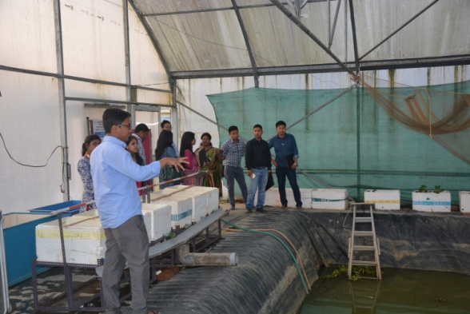A training on “Precision Farming and its Relevance to Commercialization of Horticultural Crops” was organised by EEI (NE Region), Jorhat during **Dec. 12-15, 2017**, at West Bengal with the collaboration of SAMETI, West Bengal. The topics discussed during different session of the training programme were: Precision Farming: Concept, Approach and Status, Problems and Prospects of Vegetable Production under Protected condition, Use of Mulching in Vegetable crops, High Tech Nurseries for Green House, An overview of Fertigation and practice in R.K. Mission Orchard, Narendrapur, Construction of low cost green house cum rain shelter for high rainfall areas of the region, Use of low tunnel or walk in tunnel for raising off season/ early crops, Diseases of green house vegetables, Climate Change: Its impact on Agriculture etc.

1. **Methods and Skills for Community Organisation and Entrepreneurship Development**

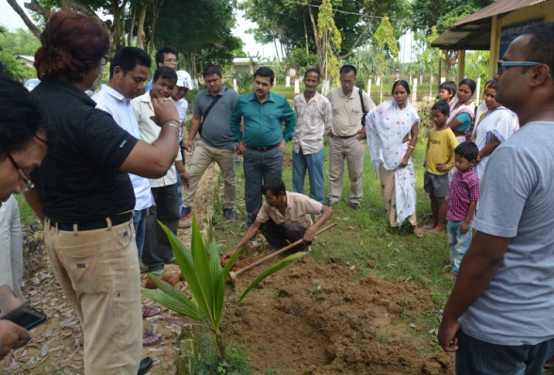A training programme on “Methods and Skills for Community Organisation and Entrepreneurship Development” was organised by EEI (NE Region), Jorhat during **Nov. 27-30, 2017**, at Tripura with the collaboration of SAMETI, Tripura. The topics discussed during different session of the training programme were: Social Value Orientation in Context to Doubling Farmers’ Income, Community Organization: Reviewing the Process & Principles to be Followed, Introducing Few Tools and Methods to Mobilize and Organize the Community, Entrepreneurship & Managerial Functions to be Performed by Entrepreneurs, A Procedure to Promote Entrepreneurship in Agricultural Extension, Phases of an Entrepreneurship Development Programme, Successful Agripreneurs in NE-Region, 7 Ps of Marketing & SWOT Analysis for Agro- entrepreneurship, Market Linkages & Support for rural Enterprises etc. Total 31 participants participated in the programme.

1. **Designing and management of skill development training programmes**

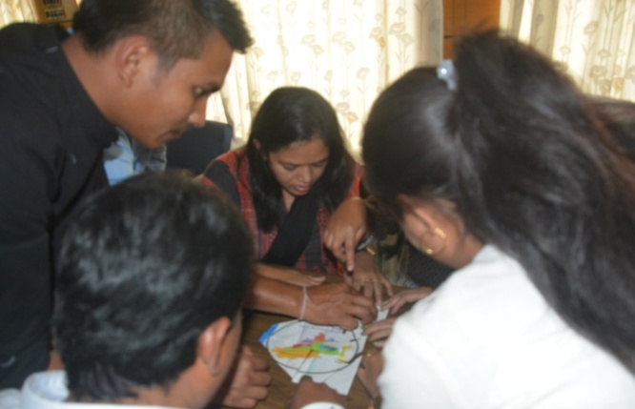The training was held at MAMETI, Mizoram from **Jan. 17th to 20th, 2018** and a total of thirty (30) participants from the department of Agri, Fishery, Vety as well as ATMA and KVKs of Mizoram participated in the programme. The steps to be followed in training module preparation were practiced in groups for skill training of farmers. Positive feedback received from all the participants regarding content, various sessions, training methodology followed, food, lodging and other facilities provided during the programme. The participants expressed their keen interest to learn about designing and management of skill development training programmes and expressed great satisfaction over the programme. Different topics covered during the programme were: Importance of Skill Development in Extension Service, Method and A.V. aids for developing Skill-Method Demonstration, identification of Skilling areas in Agriculture & allied sectors in NE states with special reference to Mizoram, Training phases, Training methods and audio visual aids, Formulation of Training Objectives, Training Management etc.

1. **Management Games and Interactive Training Tools**

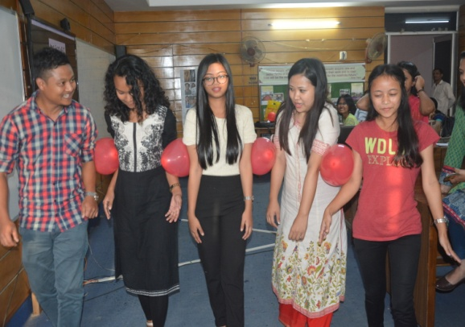 Management is an art or science is debatable. But one thing which is sure is that importance of management functions, learning basic management concepts and its application in day to day activity of corporate world has achieved tremendous acceptance in recent years. Over last couple of years, pedagogy in the management education is changing very fast, and one of the latest additions in this field is the management games. Based on the basic theoretical frameworks of management domains, several games are designed, which are focused at the basic and fundamental principles of management. Major objective of these games is to enhance the eye for details, to improve analyzing skills, to enable quick decision making, to make students cooperative and team players, and to give them long lasting impressions of the subjects, which they have learnt inside classrooms. A 5-day training programme on “**Management Games and Interactive Training Tools**” was organised during **March 6-9, 2018** by EEI (NE Region) for the Extension Functionaries of different states of North East Region. The participants were discuss and play games on Time management, Ego management, Conflict management, Team building, Communication, Leadership, Balancing work – life, Unity etc. A total of twenty eight participants from Dept. of Agriculture, ATMA and KVKs participated in the programme from different states of North East.

1. **Leadership and Team Building for Extension Personnel**

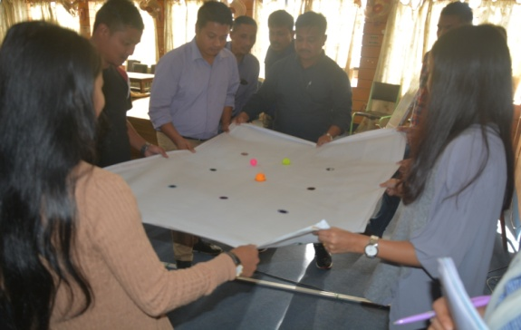Possessing a set of skills is vital for managers and leaders. It is essential to hone the skills from time to time as management is a dynamic subject. It is necessary to built knowledge on contemporary issues by getting insight from management experts, Teachers, trainers so that feasible solutions for the problems encountered in the field and in real life situation can be fruitfully encountered. Therefore it is important for extension functionaries to be oriented on the newer concepts and their application. A 4 days off campus training programme on “**Leadership and Team Building for Extension Personnel”** was organised during **March 21-24, 2018** at SAMETI, Imphal, Manipur. The topics discussed during different session of the training programme were: Concept of management and its functions applicable to Agril. Extension., Concept of organizational development and its characteristics, An overview of managerial skills, Concept and illustrations of interpersonal skills, Types and styles of leadership competencies, Team building skills and process, Change management in extension organizations, Time management skills, Stress management practices etc.

**2.9. Regional Workshop at Imphal, Manipur, Feb. 2-3, 2018**

The Regional Workshop organized by Extension Education Institute (NE Region), in collaboration with Department of Agriculture, and SAMETI, Govt. of Manipur. A total of 70 officers of Department of Agriculture, ATMA, SAMETI, EEI representing 7 NE states participated in the Workshop. The workshop was inaugurated by Shri V. Hangkhalian, Hon’ble Minister, Agri and Vety, Govt of Manipur, and the inaugural session was chaired by Dr. Suhel Akhtar, Addl. Chief Secretary (Agri), Govt. of Manipur. Technical sessions were chaired by Dr. K. P. Wasnik, Additional Commissioner, DAC&FW, MoA & FW, Dr P. K. Neog, Director, EEI (NE Region). Dr. B. Venkata Rao, Project Manager – ACABC, MANAGE, Hyderabad and Mr. J. P. Yadav, Extension Officer, ER Cell, Krishi Bhawan, New Delhi, were the resource persons in the technical sessions.

**2.10 Abstract of Research study: A study quality of skill development programmes conducted by selected KVKs of NE states**

**Objectives:**

* To study the quality and effectiveness of skill development programmes conducted by KVKs of NE states
* To identify the issues and possible suggestions related to implementation of skill development programmes conducted by KVK s of NE states

**Methodology in nutshell:**

The study was conducted during the training programmes of the year 2017-18 including both On-Campus and Off-Campus programmes. A questionnaire consists of two parts was prepared and pat I was distributed to ten Extension Functionaries of selected three states and part II was distributed to twenty participants of selected three states. A total of 90 filled up questionnaire were obtained and the data was analyzed with the help of statistical tools like frequency, mean and percentage and ranking.

**Salient Findings:**

* Out of 90 respondents, 59 per cent of the respondents felt that their knowledge gained from the training programmes were applied to a high extent while 41 per cent of them felt that the knowledge gained during the training programmes have been applied to a moderate extent.
* 70 percent respondents got engaged in different sectors after the training programme where 30 percent respondent looking for engagement who attended the training in later part of the year.
* It was encouraging to find that a huge majority (95 per cent) of the respondents had high level of satisfaction in the methodology followed in the training programmes scoring above and average of 7 on a scale of 1 to 10.
* It was found that, majority of the Extension Functionaries (96 Percent) mentioned that the adequacy of fund for organizing the training programme is very less
* 69 per cent of the respondents opined that the trainings were very relevant to their job situations while 31 per cent of them felt that the trainings were somewhat relevant.
* Majority of the respondents (83 per cent) mentioned that the practical session given in the training programme were very much useful for them whether 17 percent respondents found the practical session somewhat useful.
* 66 percent respondents found very confident about getting a job or self employment whether 25 percent respondents found confident and 9 percent respondent found somewhat confident.
* Major problems/ challenged encountered in organizing STRY training programmes were fund allotted to organize the training programme is very less, duration of practical sessions is less, implements for practical use is not sufficient for the participants etc.
* 5 major suggestions were identified for improving the training programme. These are, duration of practical sessions should be increase, more implements for the practical session is required, more exposure visit need to be conducted, proper procedure to get a loan for self employment of the participants need to be informed during the training programme and training should be organized in such a manner so that the farming activities of the participants will not be hampered and the allotment of fund for organizing the training programme should be increased.

**2.11: Skill Development Training**

The institute has started conducting one Skill Development Training Programme of Agriculture Skill Council of India on “Seed Processing Worker” on March 29, 2018 which will be completed on May 5, 2018.

**2.12.** **Significant Events**

1. **Community based biodiversity conservation and Rural Eco Tourism enterprise project**

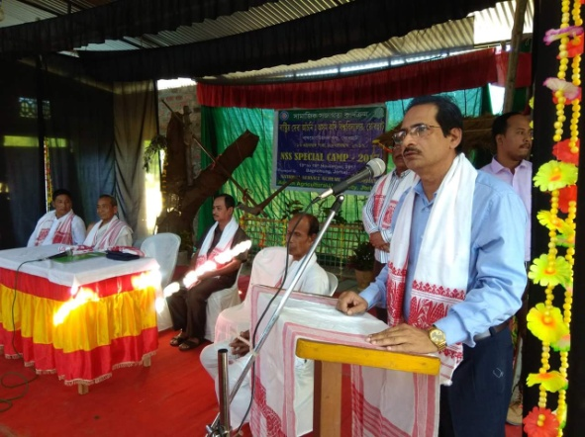EEI (NE Region) provided support to the North East Affected Area Development Society (NEADS), NGO, Jorhat in establishing a Community based biodiversity conservation and Rural Eco Tourism enterprise project, Jorhat district. NEADS, Jorhat has assured manpower support for implementation of this Project under the technical guidance of EEI (NER) and few other agencies. NEADS is a prominent NGO in Jorhat District of Assam since 2017-18.

1. **Support to post flood situation in Flood Effected Areas**

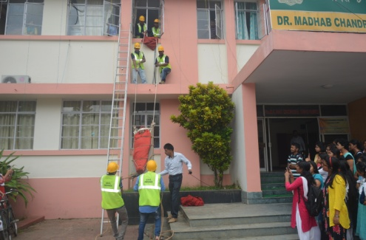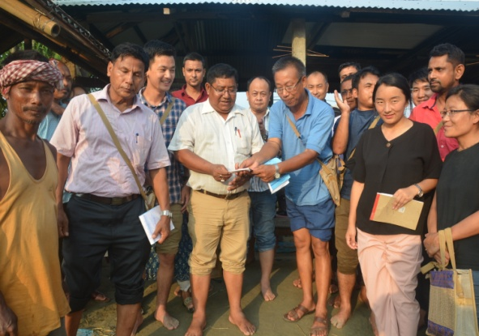As a part of the training programme on “Workshop on Climate Smart Agriculture and Disaster Management in NE States**”**  EEI provided technical, managerial and material support to Kumolia Chapori, Jorhat by collaborating with Disaster Management Cell, Jorhat district. All the twenty six (26) participants from the different states of North East including Manipur, Meghalaya, Nagaland, Arunachal Pradesh, Sikkim and Assam also donated a sum of Rs.6200.00 to the flood affected people for their wellbeing. The workshop ended on Sept. 9th, 2017 and all the participants expressed great satisfaction towards the programme.

1. 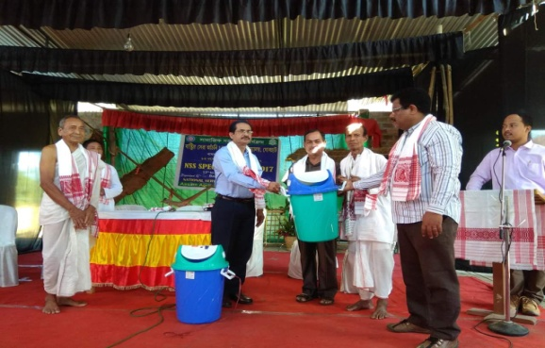**Involvement in NSS Programme**

Dr. S. Borua, faculty of EEI (NER) has provided leadership in organizing a series of NSS Programme undertaken by the Assam Agricultural University, Jorhat.

1. 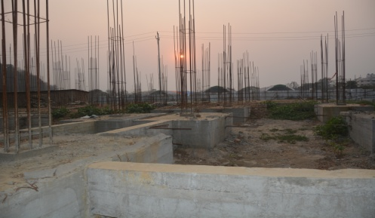**Construction of EEI (NER) administrative building**

Construction of EEI Building at AAU Campus, Khanapara, Guwahati started. The foundation of the building completed.

1. **PROPOSED PROGRAMMES for 2018-19**

EEI (NE Region) has identified the training needs of its client departments for the academic year 2018-19 by following the steps mentioned below:

***Step-1***: Compilation of the training needs obtained from the participants of the training programmes of previous years**.**

***Step-2****:* Preparation and mailing of ‘Annual Training Need Assessment Questionnaire’ to the client departments and organizations in order to obtain training needs of trust areas.

***Step 3:*** Compilation of training needs obtained from the above mentioned steps and updated in the Regional Workshop on Implementation of Central Sector Schemes and Training Planning for NE States held on Feb’ 2-3, 2018.

***Step 4:*** Finalization of thrust areas and themes of capacity building in the Annual Training Planning Workshop for MANAGE, EEIs and SAMETIs’ organized by MANAGE, Hyderabad held on February, 2018.

***Step 5:*** The finalization of academic calendar for 2018-19 of EEI (NE Region) was done in the Academic Committee meeting during 3rd Feb. 2018.

The summary of proposed programmes to be conducted by EEI, Jorhat is listed in the Table 6.

**Table 3. Summary of proposed programmes to be conducted by EEI, Jorhat during 2018-19**

|  |  |  |
| --- | --- | --- |
| **SN** | **Type of Programme** | **Number** |
| **A] Training/Workshop Programmes** | | |
| 1 | On-campus Training/workshop Programme | 8 |
| 2 | Off-campus Training/workshop Programme | 18 |
| 3 | Regional Workshop | 1 |
| 4 | Skill Development Training of 200 hrs | 2 |
| **Total Training/workshop programmes** | | **29** |
| **B] Other Academic Programmes** | |  |
| 1 | Research study | 2 |
| 2 | PGDAEM contact class + Exam ( Assam and Nagaland) | 6 |
| **Total programmes ( A + B)** | | **37** |

**3.1 Proposed Academic Calendar for the year 2018-19**

The following programmes will be conducted during 2018-19.

* + 1. **On Campus Programmes**

|  |  |  |  |
| --- | --- | --- | --- |
| SN | Programmes | Dates, Duration | Type and Venue |
|  | Use of Social Media and Video production skills for Agricultural Extension | 8-12th May, 2018 | On-campus at EEI, Jorhat |
|  | Management Games and Interactive Training Tools | 15-19th May, 2018 | On-campus at EEI, Jorhat |
|  | Workshop on scientific management of Integrated Farming systems in NE states. | 19-23th June, 2018 | On-campus at EEI, Jorhat |
|  | Soft Skills and Training Methods for Extension Personnel | 24-28th July, 2018 | On-campus at EEI, Jorhat |
|  | Extension approaches for mainstreaming farm women and popularizing gender friendly tools and practices | 21-25th Aug., 2018 | On-campus at EEI, Jorhat |
|  | Workshop on harnessing water resources and irrigation Management in NE states (with support of MANAGE, Hyderabad) | 4-8th Sept., 2018 | On-campus at EEI, Jorhat |
|  | Workshop on Disaster Preparedness and mitigation in NE States | 25 – 29th Sept., 2018 | On-campus at EEI, Jorhat |
|  | Advances in Farm Mechanization in Small Holdings | 12-16th Nov., 2018 | On-campus at EEI, Jorhat |
| Skill Development Training Programmes of 200hrs. | | | |
|  | Skill development for Floriculturist (Open Cultivation) **( 200hrs – ASCI)** | 26th Nov-22nd Dec., 2018 | On-campus at EEI, Jorhat |
|  | Skill Development on Soil and Water Testing Lab Assistant **( 200hrs – ASCI)** | 20th Jan- 19th Feb., 2019 | On-campus at EEI, Jorhat |

* + 1. **Off- Campus Programmes**

|  |  |  |  |
| --- | --- | --- | --- |
| SN | Programmes | Dates, Duration | Venue |
|  | Production and Use of Mass Media resources and Presentation Skills for Agricultural Extension | 22-25th May, 2018 | SAMETI, Manipur |
|  | Skills for using ICT in Agricultural Extension | 5-8th June, 2018 | SAMETI, Nagaland |
|  | Social Values and Work Culture for Agricultural Extension | 12-15th June, 2018 | SAMETI, Mizoram |
|  | Workshop on Export orientation in Agriculture and Allied sectors | 26-29th June, 2018 | SAMETI, Assam |
|  | Advances in Organic Farming and INM | 10-13th July, 2018 | T-SAMETI, Tripura |
|  | Workshop on Promotion of Organic Farming in Nagaland | 17-20th July, 2018 | SAMETI, Nagaland |
|  | Workshop on streamlining Agricultural Marketing and Micro Finance | 7-10th Aug., 2018 | SAMETI,  Arunachal Pradesh |
|  | Extension Skills for Implementation of Major Agricultural Development Schemes | 28-31th Aug, 2018 | SAMETI,  Sikkim |
|  | Production and Use of Mass Media resources and Presentation Skills for Agricultural Extension | 18-21st Sept., 2018 | MAMETI, Meghalaya |
|  | Community organization and Leadership skills for Extension Personnel | 18-21st Sept., 2018 | SAMETI,  Tripura |
|  | Disaster mitigation: Planning and management practices | 2-5th Oct.2018 | SAMETI,  Arunachal Pradesh |
|  | Community organization for Livestock and Dairy Development | 30th Oct-2nd Nov, 2018 | SAMETI,  Assam |
|  | Farm mechanization in small holdings in Hilly areas | 6-9th Nov.,2019 | MAMETI, Meghalaya |
|  | Disaster mitigation: Planning and management practices | 20-23rd Nov.,2018 | SAMETI,  Sikkim |
|  | Skills for using ICT in Agricultural Extension | 4-7th Dec., 2018 | SAMETI,  West Bengal |
|  | Management Games and Interactive Training tools | 15-18th Jan. 2019 | SAMETI,  Mizoram |
|  | State Level workshop on Promotion of Organic Farming in Manipur | 12-15th Feb. 2019 | SAMETI,  Manipur |
|  | Workshop on Export orientation for Agricultural Development in West Bengal | 19-22rd Feb. 2019 | SAMETI,  West Bengal |

**3.1.3 Regional Workshop:**

|  |  |  |  |
| --- | --- | --- | --- |
| SN | Programmes | Dates,Duration | Venue |
| **1.** | Regional Workshop on Implementation of Central Sector Schemes and Training Planning of EEI (NE Region) and SAMETIs of NE States | Dates to be decided | To be decided |

**3.1.4: Skill Development Training**

It is proposed to conduct 2 Skill Development Training of 200 hrs during 2018-19.

* 1. **PGDAEM Programmes**

The following PGDAEM programmes will be conducted during 2018-19

**Table 3.2. PGDAEM programmes to be conducted during 2018-19**

|  |  |  |
| --- | --- | --- |
| SN | Programme | Dates& Duration (Tentative) |
|  | Contact classes of PGDAEM 1st Semester for Assam | Dates to be decided |
|  | Contact classes of PGDAEM 1st Semester for Nagaland | Dates to be decided |
|  | PGDAEM Examination 1st  Semester, Assam | Dates to be decided |
|  | Contact classes of PGDAEM 2nd Semester for Assam | Dates to be decided |
|  | Contact classes of PGDAEM 2nd Semester for Nagaland | Dates to be decided |

* 1. **Proposed Research study**

The following research study has been proposed for 2018-19

**Research Title 1: A Study on effectiveness of Soil Health Card as perceived by the beneficiaries in NW block of Jorhat**

**Objectives:**

* To study the extent of utilization of the soil health card by farmers in order to manage the soil health
* To identify the issues and pool suggested measures in better utilization of Soil Health Card

**Methodology:**

* Primary and secondary data will be collected from the farmer respondents
* Focused Group Discussion method, Structured Interview and Semi Structured Interview method may be applied to collect the relevant information.

**Research Title 2: A Study on the utility of Kisan Call Centre and Mobile apps by member of Farm Schools and Farmers’ Groups in Darang district of Assam**

**Objectives:**

* To find out the extent of use of KCC and Mobile apps
* To study the effectiveness of KCC and mobile apps as perceived by farmers

**Methodology:**

* Primary and secondary data will be collected from the farmer respondents
* Focused Group Discussion method, Structured Interview and Semi Structured Interview method may be applied to collect the relevant information.

1. **FINANCIAL PERFORMANCE OF THE INSTITUTE, 2017-18**

A summary of the budget allocation and expenditures during 2017-18 is given hereunder:

**Statement of expenditure, 2017-18 as on** (Rs. in Lakh)

|  |  |  |  |
| --- | --- | --- | --- |
| **SN** | **Head of Expenditure** | **Allocation** | **Expenditure** |
| 1. 1 | Pay & Allowances | 133.00 | 109.17 |
| 1. 2 | Travelling Expenses | 8.00 | 7.24 |
| 1. 3 | Training Cost | 55.00 | 52.64 |
| 1. 4 | Operational Cost | 25.00 | 18.00 |
|  | Non Recurring Cost | 49.00 | 49.00 |
|  | Total | 270.00 | 236.05 |

**Status of Present Financial position** (Rs. in Lakh)

|  |  |
| --- | --- |
| Opening balance on 01-04-2017 | Rs. 34.35 |
| Fund received during 2017-18 | Rs. 235.65 |
| Total fund received | Rs. 270.00 |
| Expenditure up to 31.03.2018 | Rs. 236.05 |
| **Balance as on 31.03.2018** | **Rs. 33.95** |

**5. HIGHLIGHTS OF PERFORMANCE SINCE INCEPTION**

During last 27 years i.e. 1989 to 2017-18, EEI (NE Region) AAU, Jorhat conducted 507 number of training programmes in which a total of 12,135 extension functionaries of NE states participated. The salient aspects of performance of the institute during last 10 years are presented under the following heads:

**5.1.** Theme-wise distribution of Training Programmes

**5.2**. No. of training programmes in the last 10 years

**5.3.** Trends of participation during last 10 years

**5.4.** Trend of percentage of seat utilization during last 10 years

**5.1. Theme-wise Distribution of Training Programmes**

A total of 507 numbers of training programmes were conducted in the last 28 years. The theme wise distributions of training programmes were enlisted in the table given below**.**

**Table 5.1. Theme wise distribution of training programmes**

|  |  |  |
| --- | --- | --- |
| SN | Theme of the training programme | Numbers of training programme |
| 1 | Extension Methodology (EM) | 32 |
| 2 | Interpersonal Skills: Communication skills and motivational skills (IS) | 67 |
| 3 | Training , Human Resource Development & Institutional Capacity Building | 75 |
| 4 | Managerial Skills | 71 |
| 5 | Gender Mainstreaming : Household and Nutritional Security | 15 |
| 6 | Agricultural Technologies (AT) | 95 |
| 7 | Agricultural Extension Policy, Reforms and Processes | 88 |
| 8 | Agricultural Knowledge Management, ICT and Mass Media | 31 |
| 9 | Agri-business: Agri-Entrepreneurship and Public Private Partnership | 22 |
| 10 | Agricultural Marketing, Supply Chain Management | 11 |
| Total | | **507** |

**5.2. No. of training programmes during last 10 years**

The number of training programmes conducted in the last 10 years is given in Fig 6 (Table 1, Appendix I).

**Fig.5: No. of Training Programmes in the last 10 years**

**5.3. Trends of participation during last 10 years**

The trend of participation in the last 10 years is given in Fig. 7 (Table 1, Appendix I).

**Fig.6: Number of participants during last 10 years**

**5.4. Trends of percentage of seat utilization during last 10 years**

The figure below shows the percentage of seat utilization in the training programmes of EEI(NE Region) AAU, Jorhat in the last 10 years.

**Fig.7: Trends of seat utilization (%) during last 10 years**

**APPENDIX – I**

**Table 1: Summary of Training Programmes in the last 10 years**

|  |  |  |  |  |  |
| --- | --- | --- | --- | --- | --- |
| **SN** | **Year** | **On Campus** | **Off Campus** | **Total no.**  **of Training** | **No. of Participants** |
|  | 2007-2008 | 10 | 5 | 15 | 280 |
|  | 2008-2009 | 13 | 1 | 14 | 273 |
|  | 2009-2010 | 18 | 4 | 22 | 570 |
|  | 2010-2011 | 17 | 4 | 21 | 616 |
|  | 2011-2012 | 18 | 5 | 23 | 705 |
|  | 2012-2013 | 15 | 9 | 24 | 723 |
|  | 2013-2014 | 13 | 13 | 26 | 852 |
|  | 2014-2015 | 9 | 18 | 27 | 912 |
|  | 2015-2016 | 8 | 14 | 22 | 667 |
|  | 2016-2017 | 9 | 17 | 26 | 873 |
|  | 2017-2018 | 9 | 19 | 28 | 874 |

**Table 2: State-wise distribution of Participants in the**

**Programmes during 2017-18**

|  |  |  |  |  |  |  |
| --- | --- | --- | --- | --- | --- | --- |
| **S N** | **States** | **Total Target** | **No. of Participants in  On Campus** | **No. of Participants in Off -Campus** | **No. of Participants in Regional Workshop** | **Total no. of Participants** |
| 1 | Assam | 221 | 121 | 88 | 9 | 218 |
| 2 | Meghalaya | 83 | 33 | 64 | 3 | 100 |
| 3 | Tripura | 83 | 4 | 61 | 0 | 65 |
| 4 | Arunachal Pradesh | 83 | 14 | 61 | 2 | 77 |
| 5 | Mizoram | 83 | 13 | 61 | 2 | 76 |
| 6 | Sikkim | 83 | 8 | 64 | 0 | 72 |
| 7 | Nagaland | 83 | 16 | 60 | 3 | 79 |
| 8 | West Bengal | 83 | 0 | 30 | 1 | 31 |
| 9 | Manipur | 138 | 26 | 70 | 60 | 156 |
| **TOTAL** | | **940** | **235** | **559** | **80** | **874** |

**Appendix II**

**Table 3: Discipline/Department wise distribution of participants in the programmes during 2017-18**

|  |  |  |  |  |  |  |  |  |  |
| --- | --- | --- | --- | --- | --- | --- | --- | --- | --- |
| SN | Programmes | KVK/ ICAR/ SAU | ATMA/  SAMETI | Agri | Horti | AH & Vety | Fishery | Seri | Total |
| 1 | **Skill development for m-Extension and e-Extension with special focus on Cashless Transaction and Direct benefit Transfer** | 0 | 17 | 4 | 0 | 0 | 0 | 0 | **21** |
| 2 | **Doubling farmer’s income through Community Organisation and Entrepreneurship Development** | 0 | 12 | 7 | 0 | 0 | 0 | 0 | **19** |
| 3 | **Communication and Training Skills for Efficient Extension Service** | 0 | 19 | 4 | 0 | 2 | 2 | 2 | **29** |
| 4 | **Training Methods and Training Management Skills** | 2 | 28 | 0 | 0 | 0 | 0 | 0 | **30** |
| 5 | **Training on Organic Farming and INM** | 0 | 25 | 7 | 1 | 0 | 0 | 0 | **33** |
| 6 | **Workshop on Harnessing Agri-Market potential in NE states** | 7 | 11 | 7 | 2 | 0 | 0 | 0 | **27** |
| 7 | **Use of Social Media and Low Cost Videography** | 0 | 26 | 1 | 0 | 0 | 0 | 0 | **27** |
| 8 | **Designing and Management of Skill Development Training Programmes** | 1 | 4 | 18 | 3 | 0 | 4 | 0 | **30** |
| 9 | **Training on Organic Farming and INM** | 0 | 20 | 10 | 0 | 0 | 0 | 0 | **30** |
| 10 | **Gender friendly tools and practices, and extension approaches for mainstreaming farm women** | 6 | 19 | 2 | 1 | 2 | 0 | 0 | **30** |
| 11 | **Organic Farming Techniques and Organic Certification** | 0 | 21 | 9 | 0 | 0 | 1 | 0 | **31** |
| 12 | **Training Methods and Training Management Skills** | 0 | 34 | 0 | 0 | 0 | 0 | 0 | **34** |
| 13 | **Workshop on Climate Smart Agriculture and Disaster Management in NE States** | 6 | 16 | 2 | 0 | 0 | 2 | 0 | **26** |
| 14 | **Soft Skills for Interpersonal Effectiveness and approach towards Entrepreneurship Development** | 22 | 0 | 3 | 3 | 2 | 0 | 2 | **32** |
| 15 | **Extension Skills for Implementation of Major Agricultural Development Schemes** | 3 | 12 | 15 | 2 | 2 | 0 | 0 | **34** |
| 16 | **Workshop on Climate Smart Agriculture and Efficient Water Management** | 4 | 26 | 5 | 0 | 0 | 0 | 0 | **35** |
| 17 | **Managerial Skills and Leadership Development** | 23 | 0 | 0 | 0 | 0 | 7 | 0 | **30** |
| 18 | **Methods and Skills for Community Organization and Entrepreneurship Development** | 0 | 28 | 2 | 0 | 0 | 0 | 0 | **30** |
| 19 | **Management Games and Interactive Training Tools** | 4 | 17 | 4 | 0 | 0 | 3 | 0 | **28** |
| 20 | **Methods and Skills for Community Organization and Entrepreneurship Development** | 3 | 4 | 18 | 2 | 0 | 4 | 0 | **31** |
| 21 | **Precision Farming and its Relevance to Commercialization of Horticultural Crops** | 1 | 10 | 16 | 3 | 0 | 0 | 0 | **30** |
| 22 | **Training Methods and Training Management Skills** | 4 | 18 | 5 | 0 | 0 | 4 | 1 | **32** |
| 23 | **ICT in Agricultural Extension focusing on Mobile Apps and FCMS Applications** | 0 | 26 | 0 | 0 | 0 | 0 | 0 | **26** |
| 24 | **Designing and Management of Skill Development Training Programmes** | 3 | 14 | 6 | 1 | 2 | 2 | 0 | **28** |
| 25 | **Managerial Skills and Leadership Development** | 4 | 39 | 34 | 2 | 1 | 0 | 0 | **80** |
| 26 | **Regional Workshop on Implementation of Central Sector Schemes and Training Planning of EEI(NE Region) and SAMETIs of NE States** | 5 | 4 | 9 | 0 | 2 | 0 | 0 | **20** |
| 27 | **Management Games and Interactive Training Tools** | 0 | 13 | 17 | 0 | 0 | 0 | 0 | **30** |
| 28 | **Leadership and Team Building for Extension Personnel** | 0 | 38 | 3 | 0 | 0 | 0 | 0 | **41** |
|  | Total | **98** | **501** | **208** | **20** | **13** | **29** | **5** | **874** |
|  | **Percentage (%)** | 11.21 | 57.32 | 23.79 | 2.28 | 1.48 | 3.31 | 0.57 | **100** |

**APPENDIX III**

**Table 4: Gender distribution of participants in the programmes during 2017-18**

|  |  |  |  |  |
| --- | --- | --- | --- | --- |
| SN | Programmes | Gender | | Total |
| **Male** | **Female** |
|  | **Skill development for m-Extension and e-Extension with special focus on Cashless Transaction and Direct benefit Transfer** | 12 | 9 | 21 |
|  | **Doubling farmer’s income through Community Organisation and Entrepreneurship Development** | 15 | 4 | 19 |
|  | **Communication and Training Skills for Efficient Extension Service** | 15 | 14 | 29 |
|  | **Training Methods and Training Management Skills** | 14 | 16 | 30 |
|  | **Training on Organic Farming and INM** | 19 | 14 | 33 |
|  | **Workshop on Harnessing Agri-Market potential in NE states** | 18 | 9 | 27 |
|  | **Use of Social Media and Low Cost Videography** | 15 | 12 | 27 |
|  | **Designing and Management of Skill Development Training Programmes** | 23 | 7 | 30 |
|  | **Training on Organic Farming and INM** | 14 | 16 | 30 |
|  | **Gender friendly tools and practices, and extension approaches for mainstreaming farm women** | 13 | 17 | 30 |
|  | **Organic Farming Techniques and Organic Certification** | 22 | 9 | 31 |
|  | **Training Methods and Training Management Skills** | 15 | 19 | 34 |
|  | **Workshop on Climate Smart Agriculture and Disaster Management in NE States** | 20 | 6 | 26 |
|  | **Soft Skills for Interpersonal Effectiveness and approach towards Entrepreneurship Development** | 16 | 16 | 32 |
|  | **Extension Skills for Implementation of Major Agricultural Development Schemes** | 15 | 19 | 34 |
|  | **Workshop on Climate Smart Agriculture and Efficient Water Management** | 29 | 6 | 35 |
|  | **Managerial Skills and Leadership Development** | 20 | 10 | 30 |
|  | **Methods and Skills for Community Organization and Entrepreneurship Development** | 16 | 14 | 30 |
|  | **Management Games and Interactive Training Tools** | 13 | 15 | 28 |
|  | **Methods and Skills for Community Organization and Entrepreneurship Development** | 27 | 4 | 31 |
|  | **Precision Farming and its Relevance to Commercialization of Horticultural Crops** | 28 | 2 | 30 |
|  | **Training Methods and Training Management Skills** | 14 | 18 | 32 |
|  | **ICT in Agricultural Extension focusing on Mobile Apps and FCMS Applications** | 17 | 9 | 26 |
|  | **Designing and Management of Skill Development Training Programmes** | 20 | 8 | 28 |
|  | **Regional Workshop on Implementation of Central Sector Schemes and Training Planning of EEI(NE Region) and SAMETIs of NE States** | 63 | 17 | 80 |
|  | **Managerial Skills and Leadership Development** | 12 | 8 | 20 |
|  | **Management Games and Interactive Training Tools** | 15 | 15 | 30 |
|  | **Leadership and Team Building for Extension Personnel** | 15 | 26 | 41 |
|  | **Workshop on Export Orientation in Agriculture & allied sectors and Supply Chain Management for FPOs** |  |  |  |
|  | **Total** | **535** | **339** | **874** |
| **Percentage (%)** | **61.21** | **38.79** | **100** |

**APPENDIX IV**

**Table 5: Subject matter wise distribution of Training on Extension Management during 1989 to 2017**

|  |  |  |  |
| --- | --- | --- | --- |
| **SN** | **Subject matter** | **No. of Training programme** | **No. of participants** |
|  | Communication skills and extension teaching methods | 52 | 1034 |
|  | Training methods and training programme management | 69 | 1462 |
|  | Teamwork and managerial skill development | 56 | 1179 |
|  | Recent initiatives & On-going schemes, Prog., Supports of DAC,GOI | 3 | 388 |
|  | PRA methods and participatory planning | 22 | 502 |
|  | Formation, promotion and management of CIG/SHG/NGO | 30 | 683 |
|  | Preparation and use of audio-visual aids | 12 | 170 |
|  | Farming situation based extension (FSBE) | 12 | 135 |
|  | Entrepreneurship development | 14 | 265 |
|  | Farm journalism and Mass media production and use | 5 | 113 |
|  | Leadership development | 12 | 286 |
|  | Motivation techniques and Extension Management | 4 | 83 |
|  | IT application in Agricultural Extension and Cyber Extension | 6 | 135 |
|  | Public Private Partnership | 10 | 234 |
|  | Market led extension | 9 | 260 |
|  | Gender Sensitization and Empowerment of women | 11 | 314 |
|  | Planning, monitoring and evaluation of project | 13 | 262 |
|  | Behavioral skills development | 12 | 326 |
|  | Climate change in context to agriculture | 6 | 213 |
|  | Participatory Watershed Development | 11 | 203 |
|  | Management of IPM programme | 3 | 69 |
|  | Extension Reform | 41 | 1507 |
|  | Rice Hispa control in Jorhat District | 4 | 87 |
|  | Zonal Workshop Improvement | 4 | 57 |
|  | Cluster Training Improvement | 5 | 86 |
|  | Capacity building of Field Management Committees in Assam | 5 | 150 |
|  | Action Research | 1 | 16 |
|  | Plant Variety Protection and Farmer’s Rights | 3 | 89 |
|  | Nutrition Education and Agriculture Interface for rural health | 1 | 28 |
|  | Process documentation and Record keeping | 4 | 75 |
|  | Advanced Technologies in Organic Farming | 9 | 274 |
|  | Information &Communication Technology (ICT) | 5 | 111 |
| **A** | **TOTAL** | **463** | **10766** |

**Table 6: Discipline wise distribution of training programme on technological aspects during 1989 to 2017**

|  |  |  |  |
| --- | --- | --- | --- |
| **SN** | **Subject matter** | **No. of Training programme** | **No. of participants** |
| 1 | Agricultural Technology | 33 | 1058 |
| 2 | Animal husbandry and Vety | 8 | 225 |
| 3 | Horticultural technology | 2 | 51 |
| 4 | Sericulture Technology | 1 | 35 |
| **B** | **TOTAL** | **44** | **1369** |

**Grand Total (A+B)**

Total number of training programme : **507**

Total number of participants : **12135**